CHECKPOINT Mongo DB

1. Create a database called "contact"

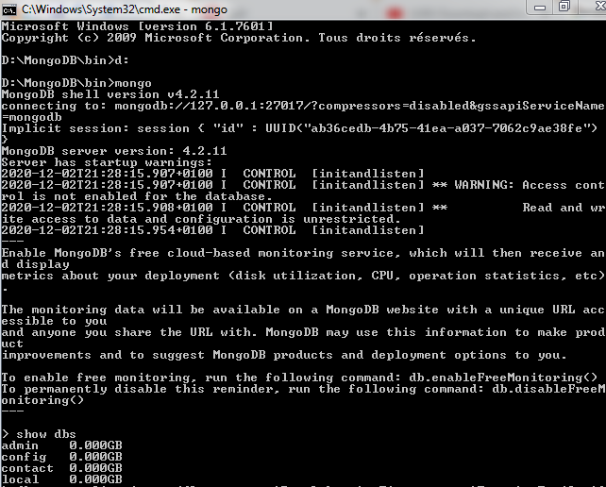

1. Insert these documents  in "contactlist"

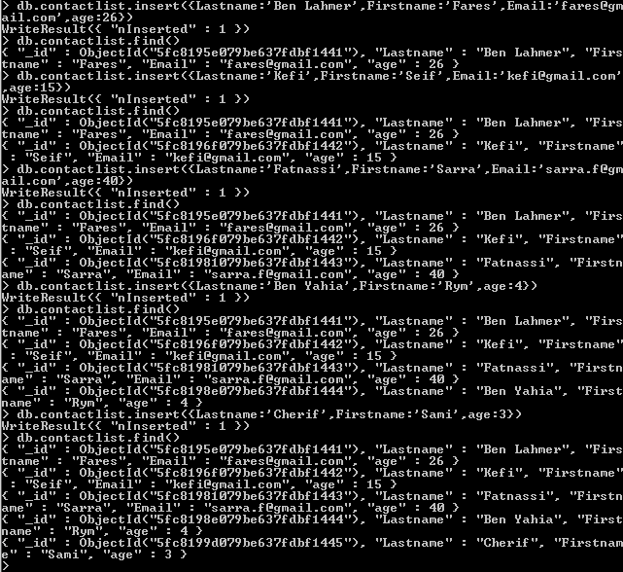

Find().pretty()

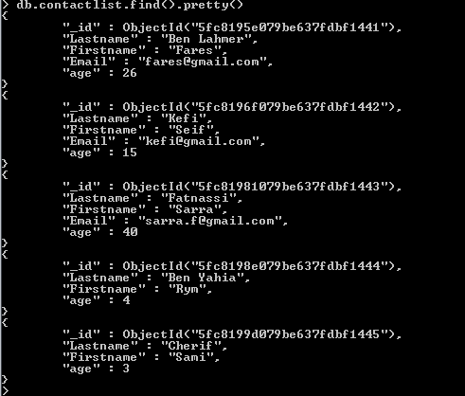

1. Display all the information about only one person using his id

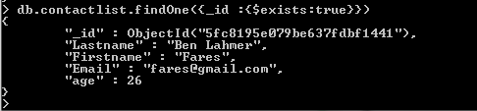

1. Display all the contact list having age>18

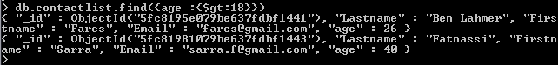

1. Display all the contact list having age>18 and name containing "ah"



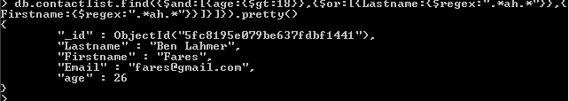

1. Change the contact first name of "kefi Seif" by "Kefi Anis"



1. Delete the contact list having age < 5



1. Display all the contact list

